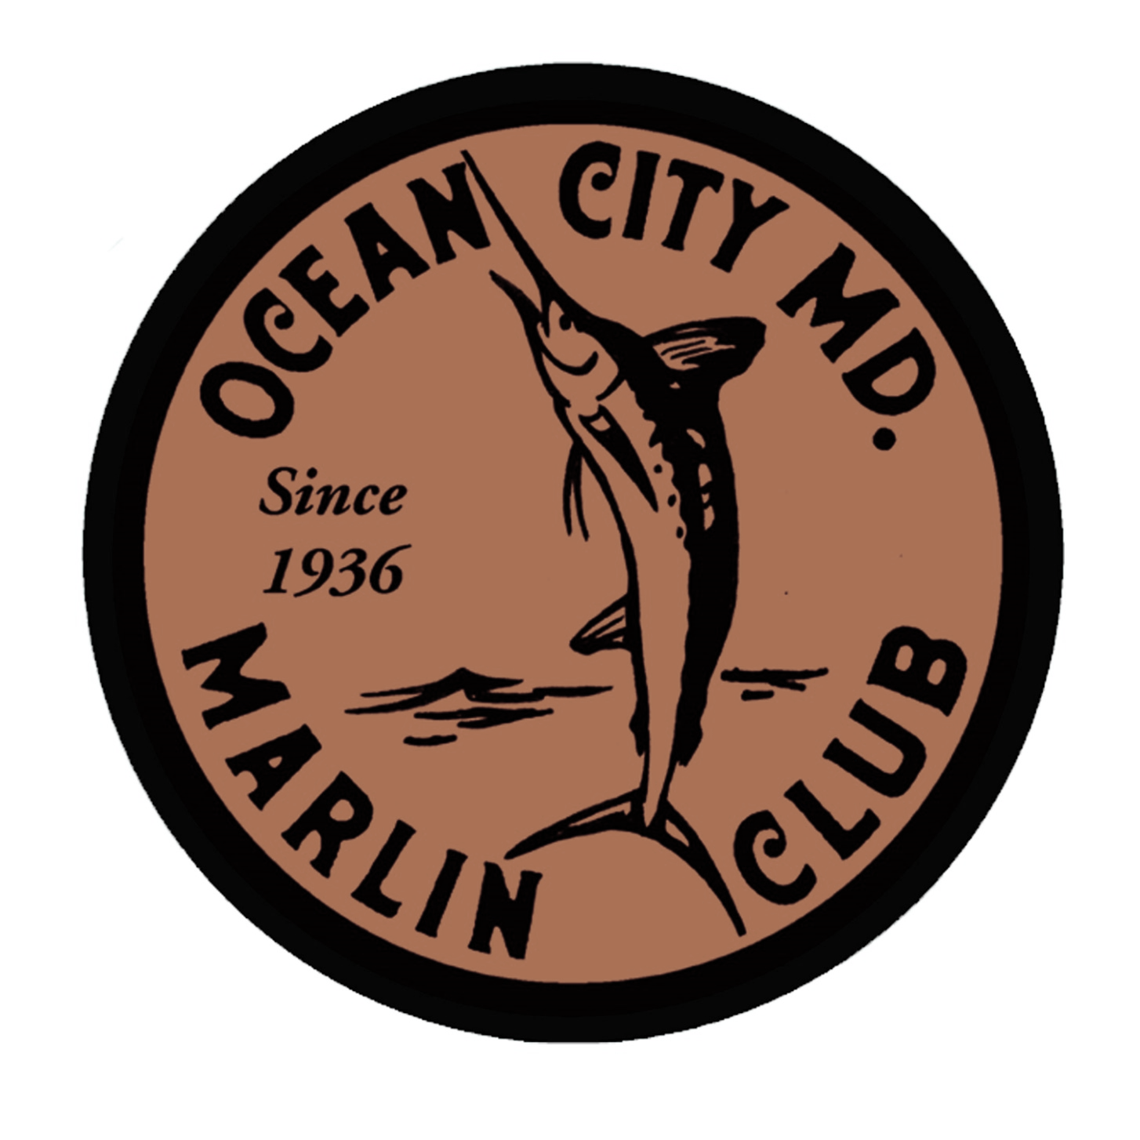

**OCMC Specials Menu**

**Week of Aug 17 - Aug 21,**

Dine-In Only - No carry-out

**Soup**

Maryland Crab **$10**

**Egg Dujour**

Pulled Pork w/ Jack Daniels BBQ, crispy fried onions & scallions **$8**

**Appetizer**

Pan seared scallops in bacon cream sauce w/ bacon & asparagus **$14**

**Salad**

Chesterfield heirlooms (Pittsville, MD) caprese salad w/ fresh mozzarella. Basil puree, balsamic reduction & EVOO **$14**

**Chef’s Grilled Cheese**

Smoked Gouda & Granny Smith apple on sourdough **$10**

**Entrée**

**THE PORK CHOP**: Love dusted pork chop w/ demi-glaze. Served with starch & vegetable **$32**